**Name: ADWAIT S PURAO**

**UCID:2021300101**

**Class:** CE(B2)

**Experiment No.:** 7

**Objectives:**

It should include following points to achieve the listed objectives.

* Scanned copy of the handwritten or printed material
* Circuit diagrams (Built using Sequel/MATLAB)
* Output table of parameters/ graphs obtained using simulator
* Comparison of theoretical and simulated results
* Learning outcome/ conclusion
* References

**Objectives:**

**1) Review the literature**

**a) To define line voltage, line current, phase voltage, phase current, balanced load**

LINE VOLTAGE : the voltage of a power transmission circuit or distribution circuit up to the point of transformation or utilization.

LINE CURRENT : Line current is the measured amount of direct current flowing in a pipeline. It is an indicator of the degree of reactivity and corrosion experienced on the pipeline's surface.

PHASE VOLTAGE: The voltage measured between any line and neutral.

PHASE CURRENT : Phase current is the current through any one component comprising a three-phase source or load.

BALANCED LOAD : A load connected to an electric circuit (as a three-wire system) so that the currents taken from each side of the system are equal and the power factors are equal.

To verify the relationship between line/phase voltage and line/phase currents in case of star and delta connection.

Star and Delta Connections are the two types of connections in a 3 – phase circuits. A Star Connection is a 4 – wire system and a Delta Connection is a 3 – wire system.

|  |  |
| --- | --- |
| STAR CONNECTION(Y) | DELTA CONNECTION |
| A star connection is a 4-wire connection | A delta connection is a 3-wire connection. |
| Two types of star connection systems are possible: 4wires 3-phase system and 3 wire 3 phase system. | In delta connection only 3-wire 3 phase systems is possible. |
| The common point of the star connection is neutral point. | There is no common point. |
| Line current phase current are same. | Line current is root three times the phase current. |
| Line voltage and phase voltage is different. | Line voltage and phase voltage is same. |
|  |  |

**b) To know how two wattmeters can be used to measure power in 3 phase circuit**

**In a balanced 3-wire, 3-phase load circuit the power in each phase is equal and, therefore, the total power of the circuit can be determined by multiplying the power measured in any one phase. Hence, the power measurement in three-phase, three-wire circuits can be carried out by using the one wattmeter only.**

**c) To find among star and delta connection, in which case more power would be present.**

**In delta connection more power is present.**

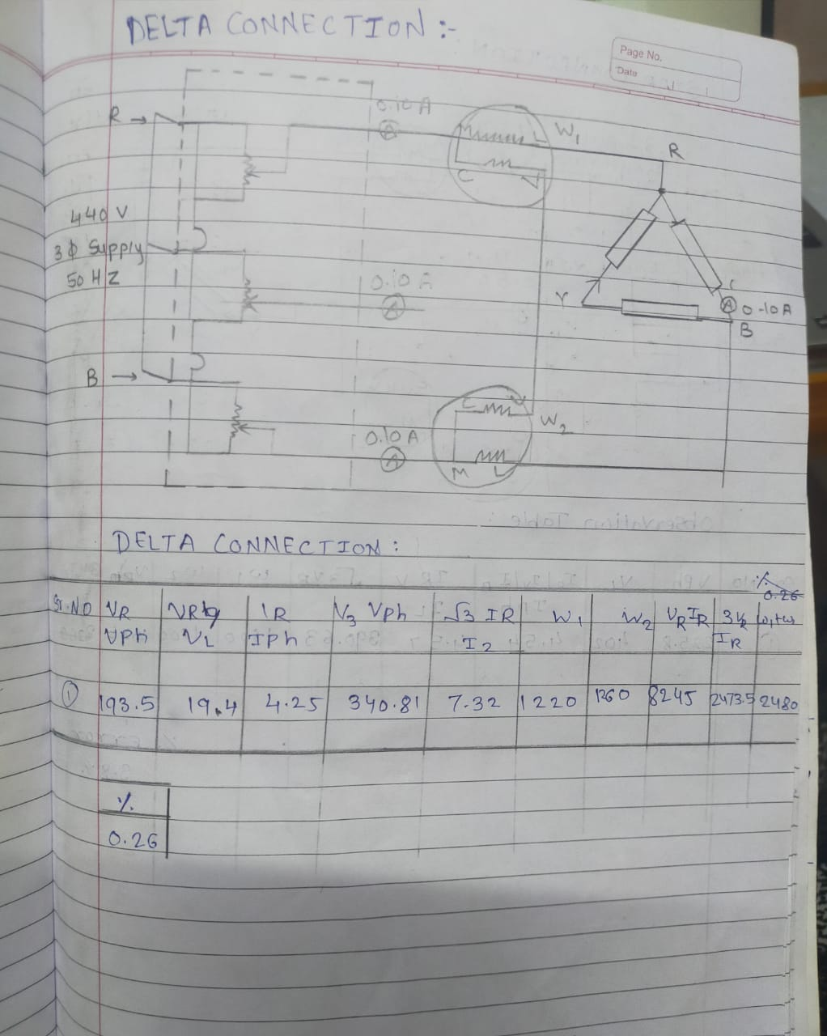

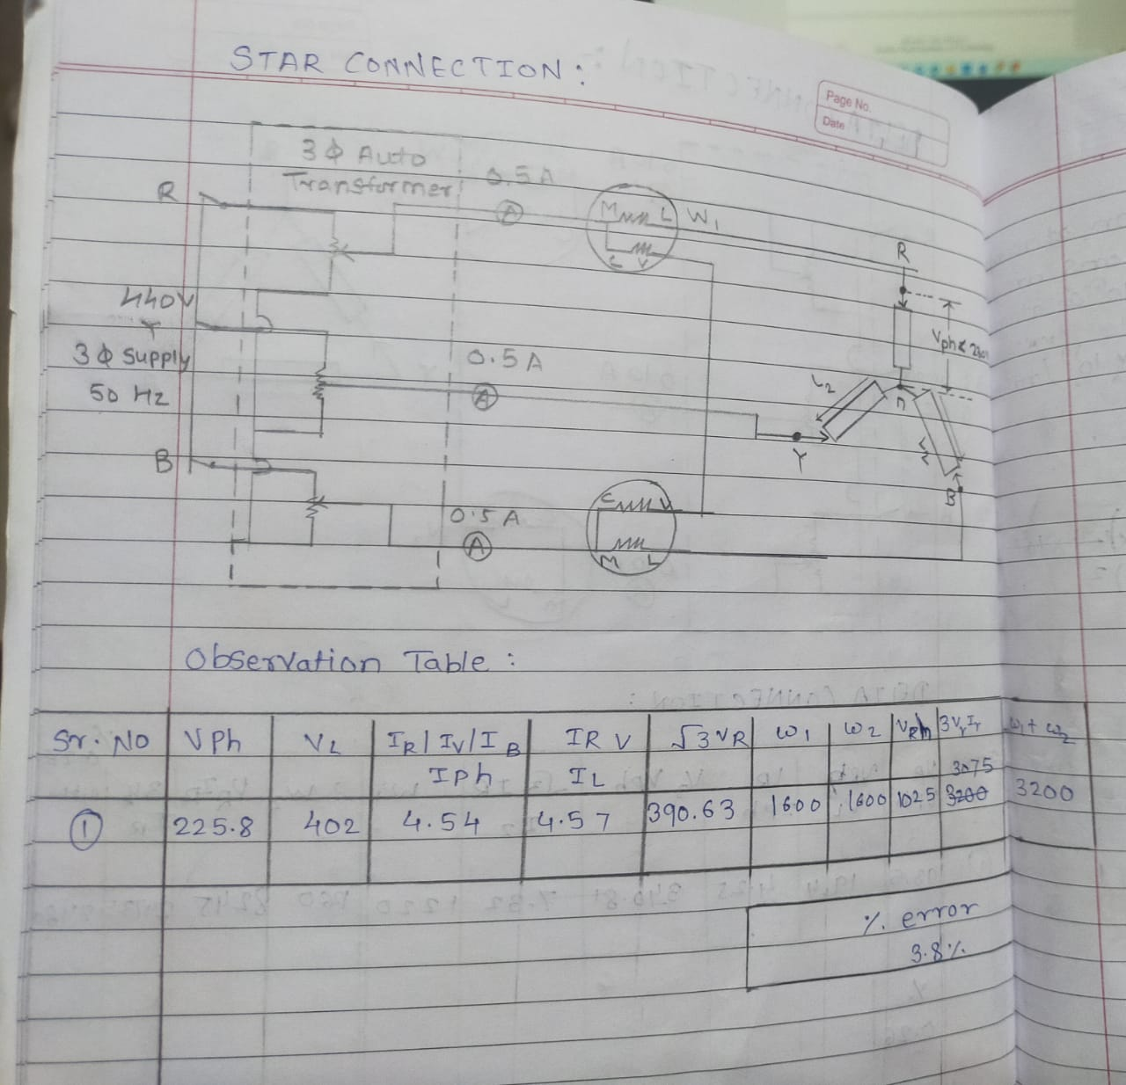

**CONCLUSION:**

